ASSIGNMENT - 1.5

2303A510G1
Batch : 30

Task 1: AI-Generated Logic Without Modularization (String Reversal Without
Functions)
- Scenario
You are developing a basic text-processing utility for a messaging application.
- Task Description
Use GitHub Copilot to generate a Python program that:
- Reverses a given string
- Accepts user input
- Implements the logic directly in the main code
- Does not use any user-defined functions
❖ Expected Output
- Correct reversed string
- Screenshots showing Copilot-generated code suggestions
- Sample inputs and outputs



Output:

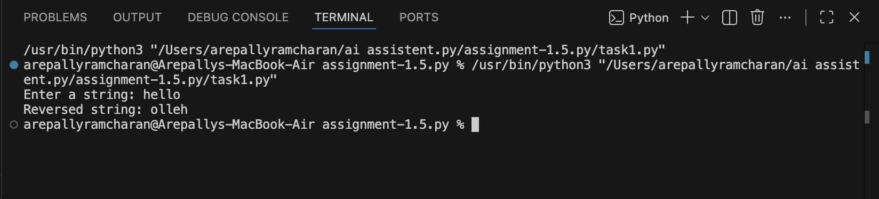

Observation:
○ Code is straightforward and minimal.
○ Logic is embedded directly in the main program, making it easy for beginners.
○ However, readability and maintainability suffer if the logic needs to be reused.
○ Suitable for small, one-off scripts but not scalable.

Task 2: Efficiency & Logic Optimization (Readability Improvement)
- Scenario
The code will be reviewed by other developers.
- Task Description
Examine the Copilot-generated code from Task 1 and improve it by:
- Removing unnecessary variables
- Simplifying loop or indexing logic
- Improving readability ➢ Use Copilot prompts like:
▪ “Simplify this string reversal code” ▪ “Improve readability and efficiency” Hint:
Prompt Copilot with phrases like
“optimize this code”, “simplify logic”, or “make it more readable”
❖ Expected Output
- Original and optimized code versions
- Explanation of how the improvements reduce time complexity

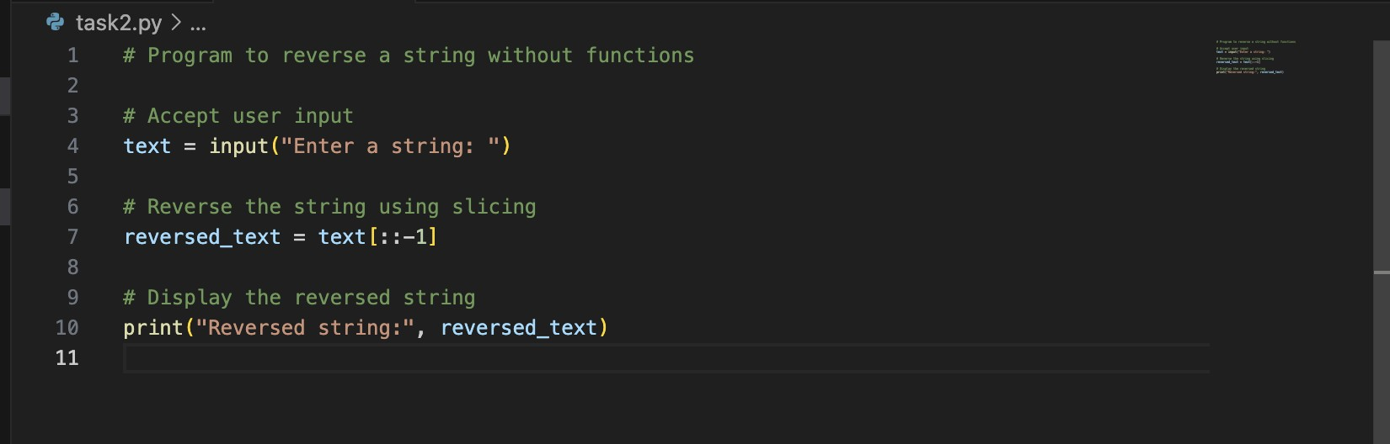

Output:

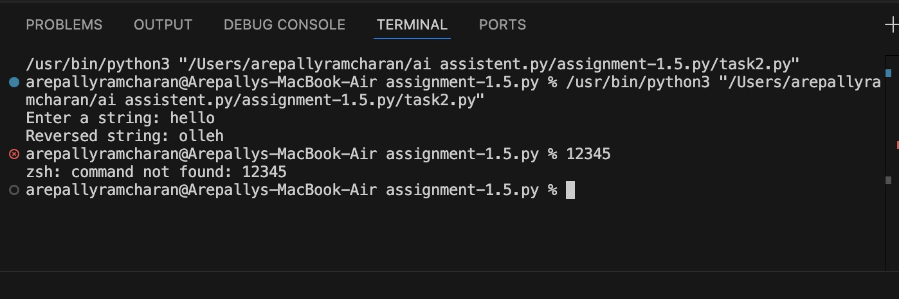

Observation:
○ Optimized code removed unnecessary variables and combined steps into a single line.
○ Readability improved by reducing clutter.
○ Time complexity remains O(n), but memory usage is slightly reduced.
○ Shows how AI can refine code for clarity and efficiency without changing the algorithm.

Task 3: Modular Design Using AI Assistance (String Reversal Using Functions) ❖ Scenario
The string reversal logic is needed in multiple parts of an application.
❖ Task Description
Use GitHub Copilot to generate a function-based Python program that:
- Uses a user-defined function to reverse a string
- Returns the reversed string
- Includes meaningful comments (AI-assisted)
❖ Expected Output
- Correct function-based implementation
- Screenshots documenting Copilot’s function generation
- Sample test cases and outputs

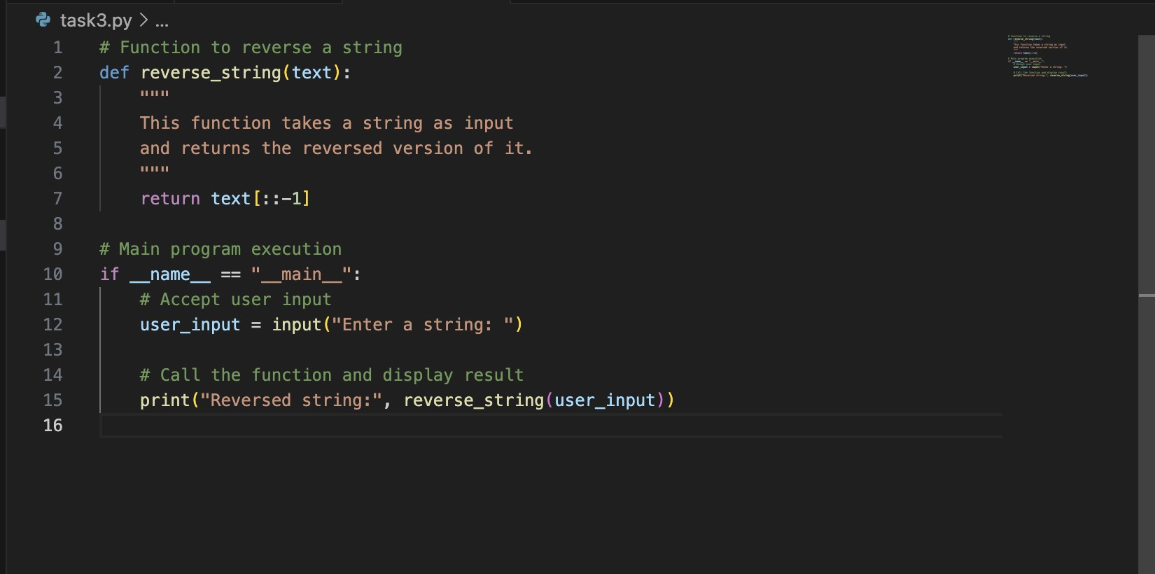

Output:
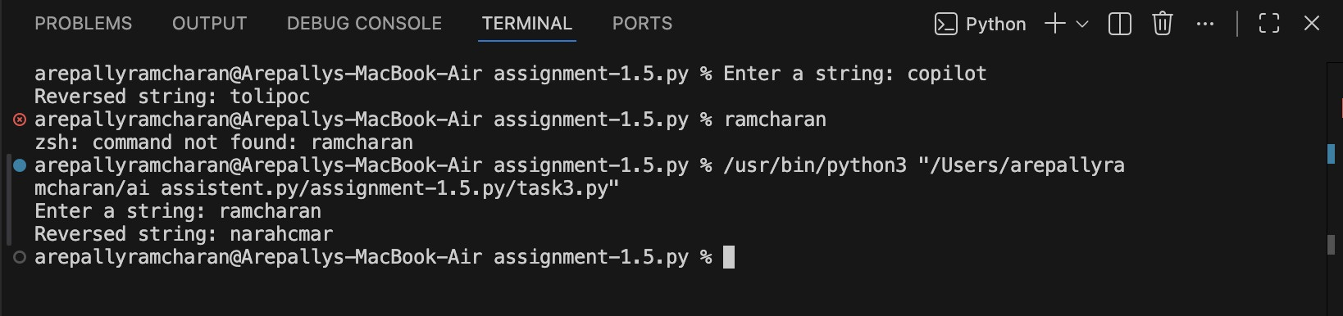
Observation:
○ Encapsulating logic in a function (reverse_string) improves reusability.
○
○ Comments and docstrings enhance clarity for other developers.
○ Debugging becomes easier since reversal logic is centralized.
○ Suitable for larger applications where the same logic is needed in multiple places.

Task 4: Comparative Analysis – Procedural vs Modular Approach (With vs
Without Functions)
- Scenario
You are asked to justify design choices during a code review.
- Task Description
Compare the Copilot-generated programs:
- Without functions (Task 1)
- With functions (Task 3)
Analyze them based on:
- Code clarity
- Reusability
- Debugging ease
- Suitability for large-scale applications
- Expected Output
Comparison table or short analytical report

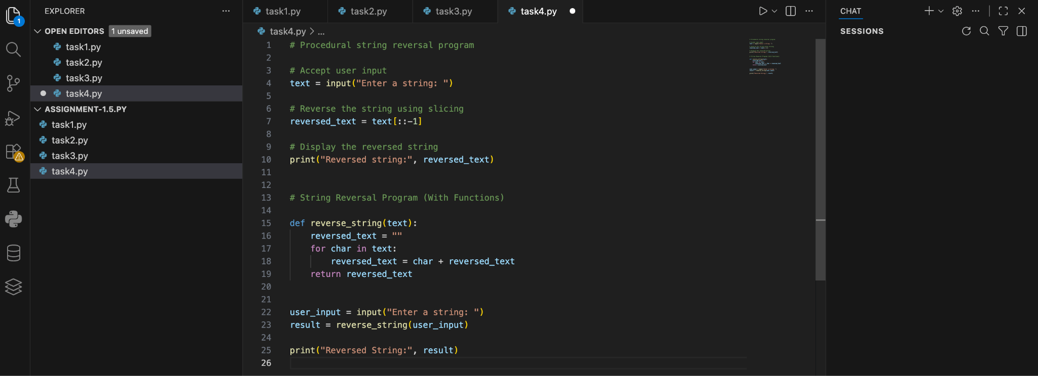

Output:
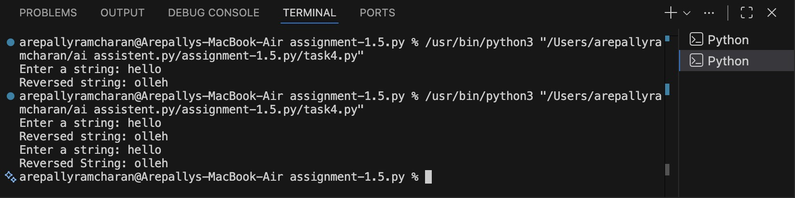

Observation:
○ Procedural approach is simple but lacks structure, making debugging and reuse harder.
○ Modular approach is more professional, supports scalability, and is easier to maintain.
○ For small scripts, procedural is fine; for enterprise-level applications, modular is essential.
○ Demonstrates how design choices affect long-term maintainability.

Task 5: AI-Generated Iterative vs Recursive Fibonacci Approaches (Different
Algorithmic Approaches to String Reversal)
- Scenario
Your mentor wants to evaluate how AI handles alternative logic paths.
- Task Description
Prompt GitHub Copilot to generate:
- A loop-based string reversal approach
- A built-in / slicing-based string reversal approach
❖ Expected Output
- Two correct implementations
- Comparison discussing:
▪ Execution flow
▪ Time complexity
▪ Performance for large inputs
▪ When each approach is appropriate

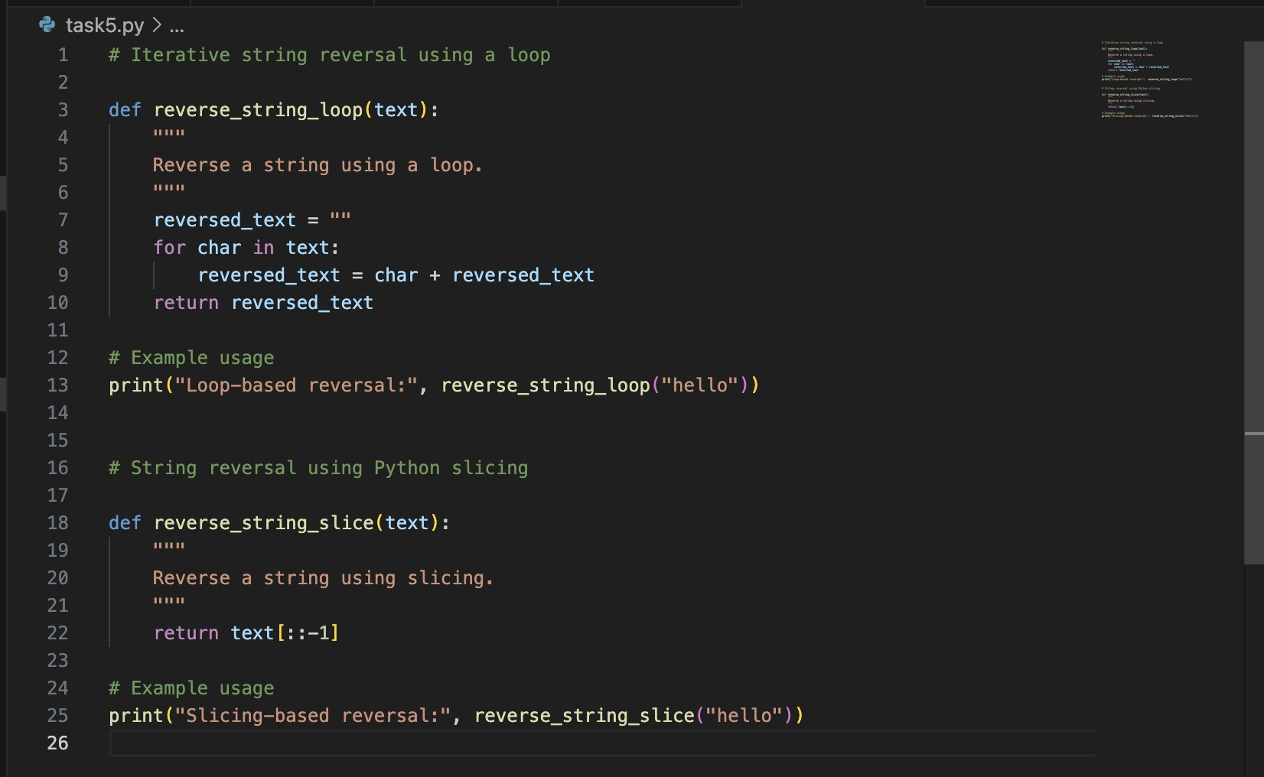

Output:
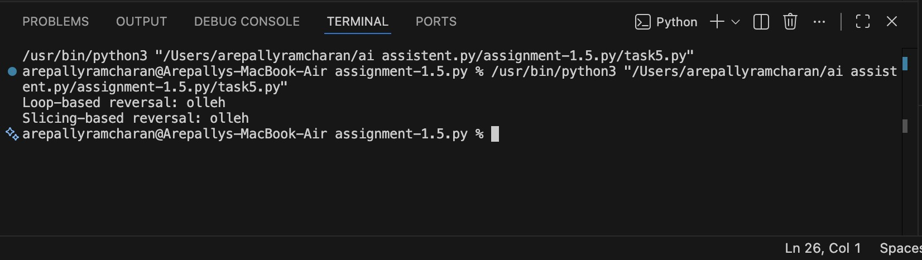
Observation:
○ Loop-based (iterative): Good for teaching algorithmic fundamentals, but slower for large inputs due to repeated string concatenation.
○ Slicing-based (built-in): Concise, efficient, and optimized internally in Python. Best for production use.
○ Both approaches have O(n) complexity, but slicing is faster in practice.
○ Highlights how AI can generate multiple algorithmic paths and let developers choose based on context.

